
Department of CSE

B.Tech. CSE Trimester -5

2520030078
M.Apoorva

Cloud Infrastructure and Services
25CS2206E

LAB RECORD
2026

Experiment -1

AIM: Create an IAM user with programmatic access only, download the access key and secret key, and document the steps with screenshots

Description: AWS IAM (Identity and Access Management) is a service used to securely manage access to AWS resources.\
It allows users to create and manage users, roles, and permissions.\
It provides secure authentication using Access Key ID and Secret Access Key.\
It helps protect AWS resources by controlling user access.

Steps:

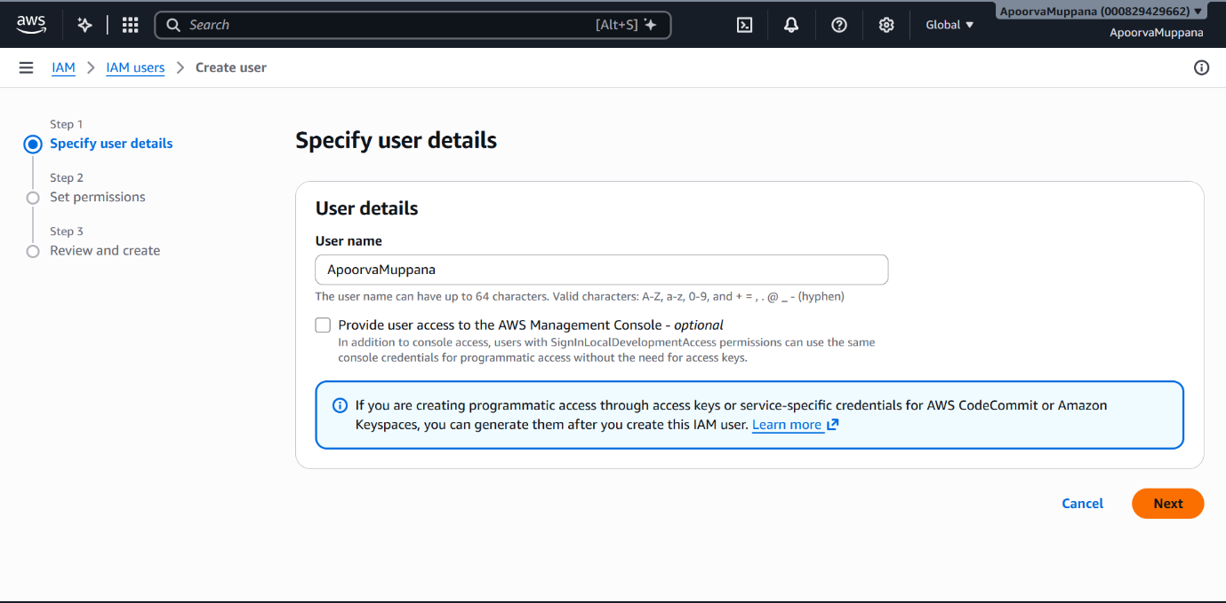

In IAM users we create a user and then give a username

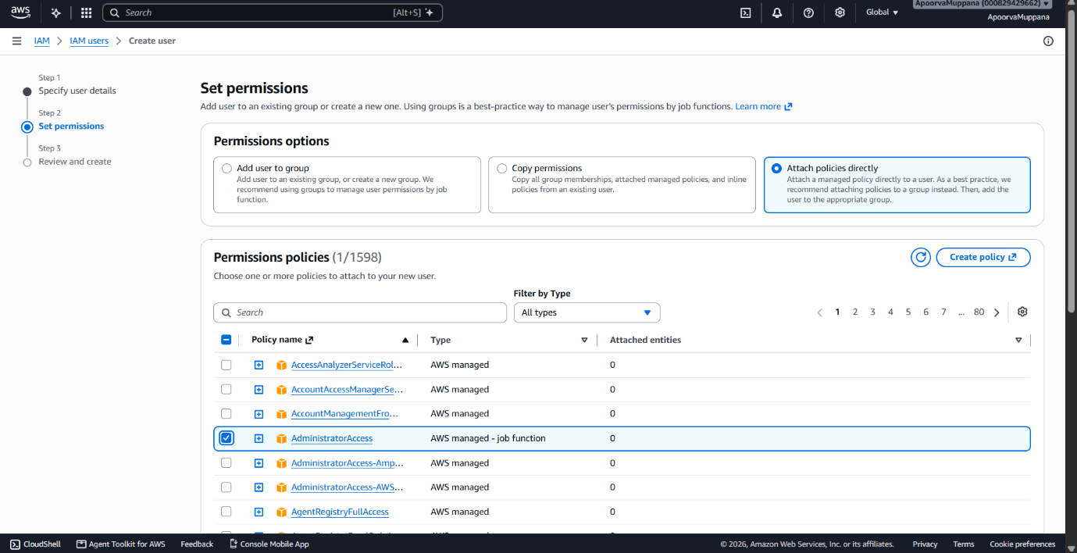

Tag is usually not necessary(optional) and we can create a user
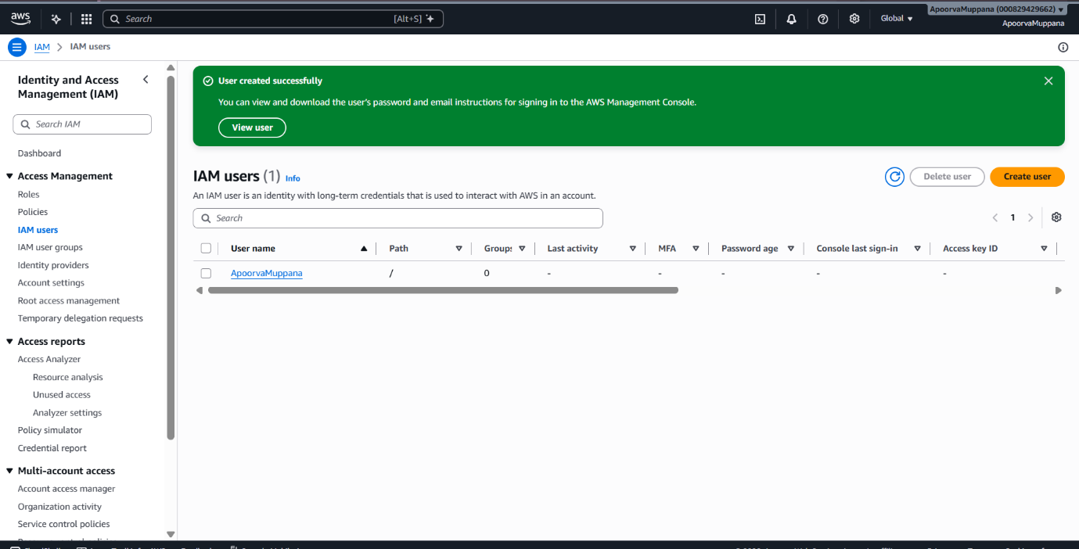

User created

PROGRAMMATIC ACCESS KEY:
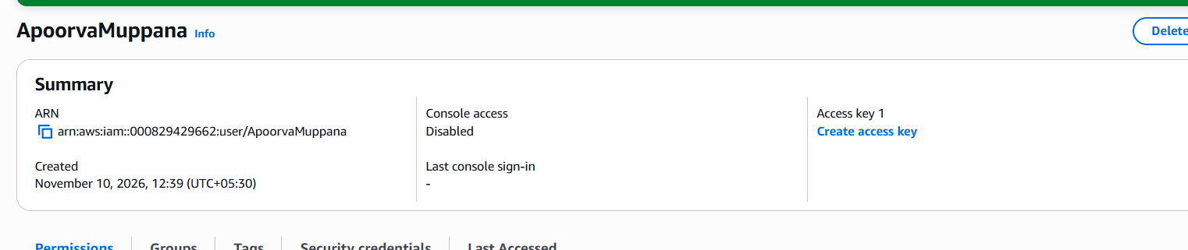

When we open user-1 in the right we can create an access key
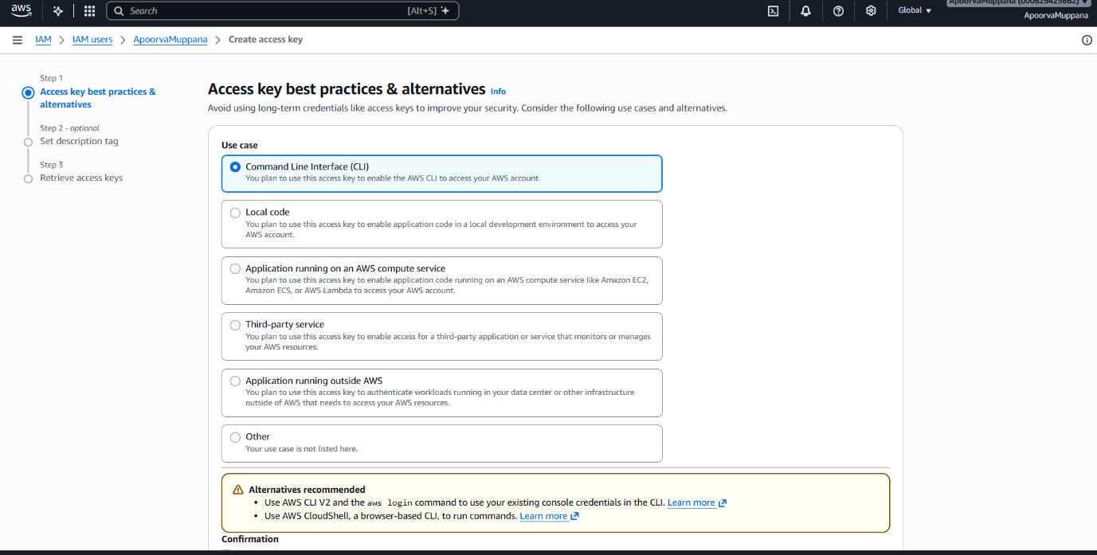

In the use case choose Command Line Inteface(CLI)
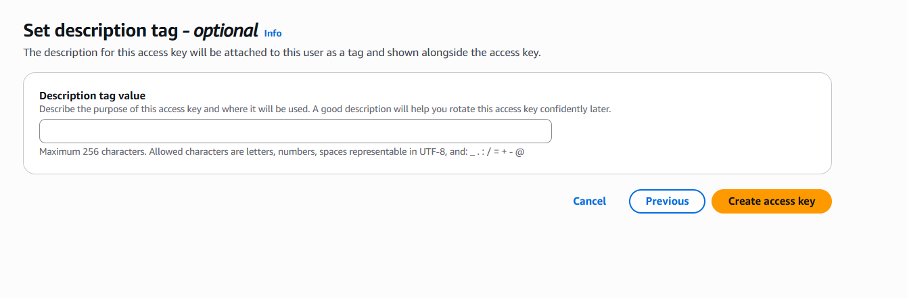

Description tag is optional and create access key
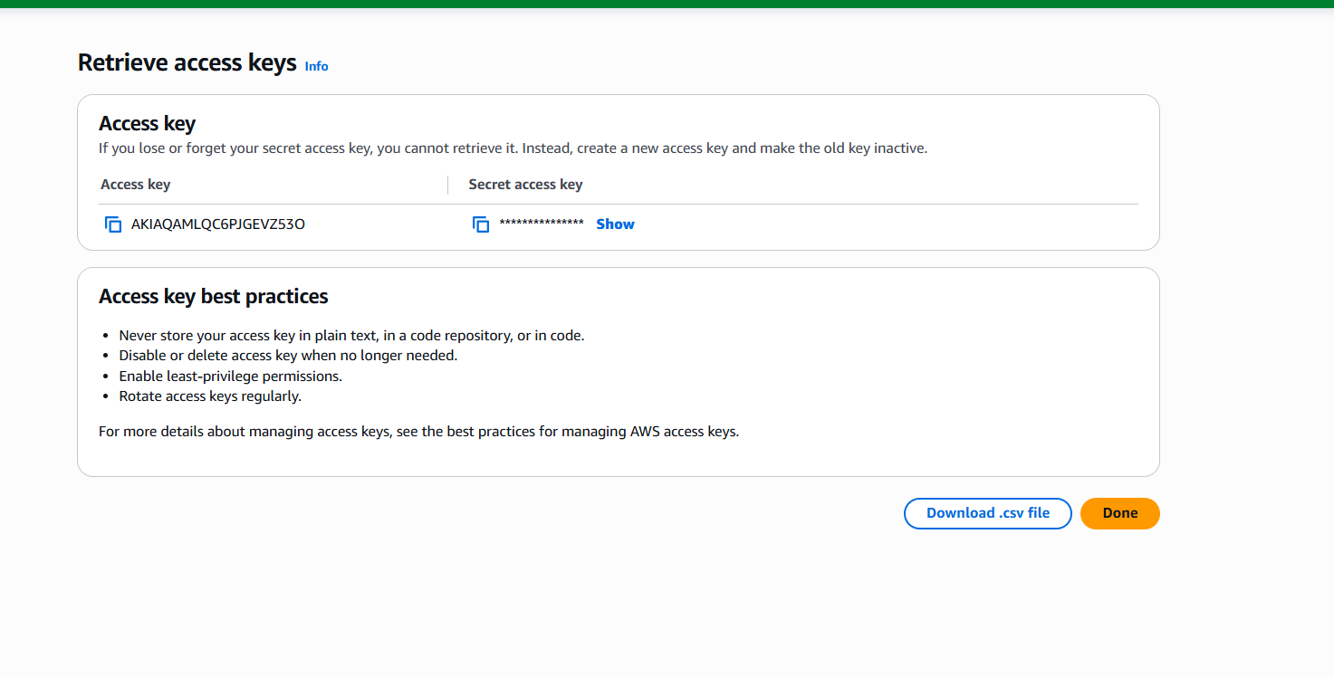

Download .csv file and the process is done

Output: 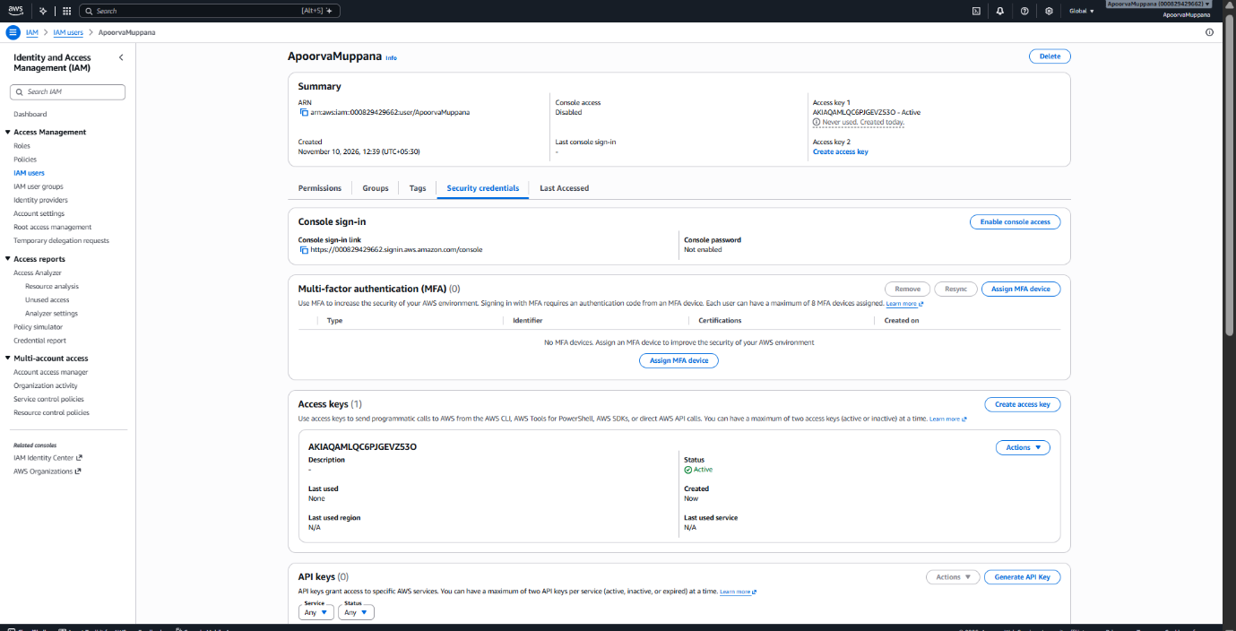

AIM- .Then set up a billing alert for the account so that an email is received when the Free Tier limit is about to be crossed.

Description-AWS Billing and Cost Management is a service used to monitor and manage AWS expenses.\
It helps track service usage, costs, and payments.\
It allows users to set up billing alerts and budget notifications.\
It helps avoid unexpected charges by monitoring AWS Free Tier usage.

Steps- 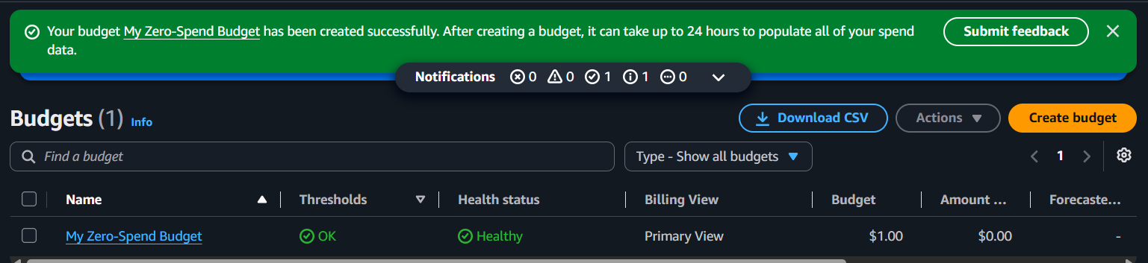
- In the right corner choose create budget
- Go to budget system required
- Let the default options be themselves
- Add email address
- And the budget is created.

OUTPUT-


